SIMATS ENGINEERING
ASSESSMENT TOOL 2 – PSEUDOCODE WRITING TASK (ALGORITHM DESIGN)
Course Name: Internet Programming | Course Code: CSA4308
COURSE OUTCOME COVERED
CO-4: Formulate data-driven web solutions using XML, XSLT, and JSP within the MVC framework. (L4)
Assessment Tool: Pseudocode Writing Task (Algorithm Design)
Weightage: 20% Total Marks: 25
Question 1: XML Parsing Algorithm
Write a detailed pseudocode algorithm to parse an XML document that contains structured data such as user or product details. Your algorithm should clearly describe the steps involved in loading the XML file, accessing its elements, traversing through nodes, extracting required data, and displaying the output in a readable format. Ensure that the logic handles hierarchical structure properly.
Sample XML Structure Assumed
<users>
<user>
<id>101</id>
<name>John Doe</name>
<email>john@example.com</email>
</user>
<user> ... </user>
</users>
Pseudocode Algorithm
ALGORITHM ParseXML(filePath)
BEGIN
// Step 1: Load the XML file
xmlDocument ← LOAD_FILE(filePath)
IF xmlDocument is NULL OR malformed THEN
PRINT "Error: Unable to load or parse XML file"
EXIT
END IF

// Step 2: Access the root element
rootElement ← xmlDocument.GET_ROOT_ELEMENT() // e.g., <users>
recordList ← EMPTY LIST

// Step 3: Traverse all child (record) nodes under the root
FOR EACH childNode IN rootElement.GET_CHILDREN() // e.g., each <user>
record ← TraverseNode(childNode)
APPEND record TO recordList
END FOR

// Step 4: Display extracted data in readable format
FOR EACH record IN recordList
PRINT "-----------------------------"
FOR EACH (fieldName, fieldValue) IN record
PRINT fieldName + ": " + fieldValue
END FOR
END FOR
END

// Recursive helper to handle nested / hierarchical elements
FUNCTION TraverseNode(node)
BEGIN
record ← EMPTY KEY-VALUE MAP
FOR EACH child IN node.GET_CHILDREN()
IF child.HAS_CHILDREN() THEN
// Nested element (e.g., <address><city>..</city></address>)
record[child.tagName] ← TraverseNode(child) // recursive call
ELSE
// Leaf element — holds actual text data
record[child.tagName] ← child.GET_TEXT_CONTENT()
END IF
END FOR
RETURN record
END
Explanation of Key Steps
- Loading the file: The algorithm first loads the XML file into a DOM (Document Object Model) tree structure, with error handling for missing/malformed files.
- Accessing elements: The root element (e.g., <users>) is retrieved first, since all data records exist as its children.
- Traversing nodes: A FOR EACH loop walks through every child of the root (each individual <user> or <product> record).
- Handling hierarchy: The TraverseNode function is written recursively — if a child element itself contains further child elements (e.g., a nested <address> block), the function calls itself again, so the algorithm correctly handles XML of any nesting depth, not just a flat structure.
- Extracting and displaying data: Leaf elements (those with no further children, e.g., <name>John Doe</name>) contribute their tag name and text content as a field in the record; once every record is built, a final display loop prints each record's fields in a clearly separated, readable format.
Question 2: MVC Workflow
Write a pseudocode representation of the MVC (Model–View–Controller) workflow in a web application. Your answer should clearly illustrate how a user request is received, processed by the Controller, how the Model interacts with the database, and how the View generates and returns the response to the user. Include all major steps involved in request handling and response generation.
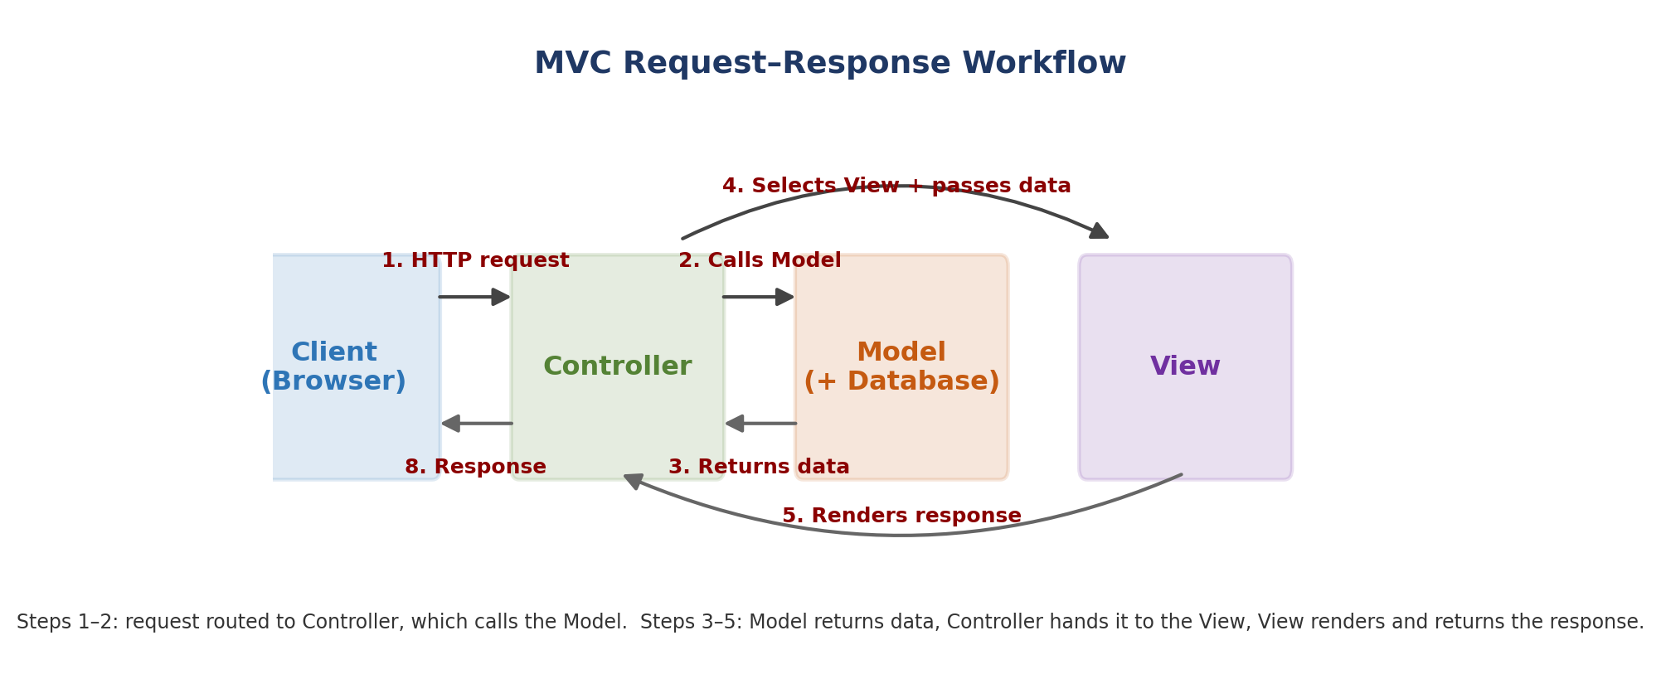
Figure 1: The MVC request–response workflow — Controller mediates between Model and View.
Pseudocode Algorithm
ALGORITHM MVC_Workflow(clientRequest)
BEGIN
// Step 1: Client sends a request
request ← clientRequest // e.g., HTTP GET /products?id=5

// Step 2: Front Controller / Dispatcher routes the request
targetController ← DISPATCHER.MAP_URL_TO_CONTROLLER(request.url)

// Step 3: Controller processes the request
CALL targetController.HandleRequest(request)
END

FUNCTION Controller.HandleRequest(request)
BEGIN
params ← EXTRACT_PARAMETERS(request)
IF NOT VALIDATE(params) THEN
RETURN View.Render("errorPage", "Invalid input")
END IF

// Step 4: Controller calls the Model to perform business logic
data ← CALL Model.ProcessRequest(params)

// Step 5: Controller selects the appropriate View and passes data
selectedView ← DETERMINE_VIEW(request)
response ← CALL View.Render(selectedView, data)

// Step 6: Send the generated response back to the client
RETURN response
END

FUNCTION Model.ProcessRequest(params)
BEGIN
connection ← DATABASE.CONNECT()
query ← BUILD_QUERY(params)
resultSet ← connection.EXECUTE(query)
businessData ← APPLY_BUSINESS_LOGIC(resultSet)
connection.CLOSE()
RETURN businessData
END

FUNCTION View.Render(viewName, data)
BEGIN
template ← LOAD_TEMPLATE(viewName)
htmlOutput ← BIND_DATA_TO_TEMPLATE(template, data)
RETURN htmlOutput // sent back to client as the HTTP response
END
Explanation of Key Steps
- Request reception and routing: The client's HTTP request first reaches a dispatcher/front controller, which maps the URL to the correct Controller — keeping routing logic separate from business logic.
- Controller's role: The Controller extracts and validates request parameters, then delegates all actual data processing to the Model — it never touches the database or generates HTML directly, keeping responsibilities cleanly separated.
- Model's role: The Model is solely responsible for connecting to the database, executing queries, and applying business rules, returning plain data (not formatted output) back to the Controller.
- View's role: The Controller passes the Model's data to a View, whose only job is to bind that data into a template and produce the final HTML — no business logic lives in the View.
- Response generation: The rendered HTML from the View becomes the HTTP response sent back to the client's browser, completing the request–response cycle.
Question 3: JSP Request Flow
Write a detailed pseudocode algorithm to explain the request–response flow in a JSP-based web application. Your algorithm should include steps such as client request initiation, server processing, interaction with backend components (like Servlets or database), and generation of dynamic content that is sent back to the client.
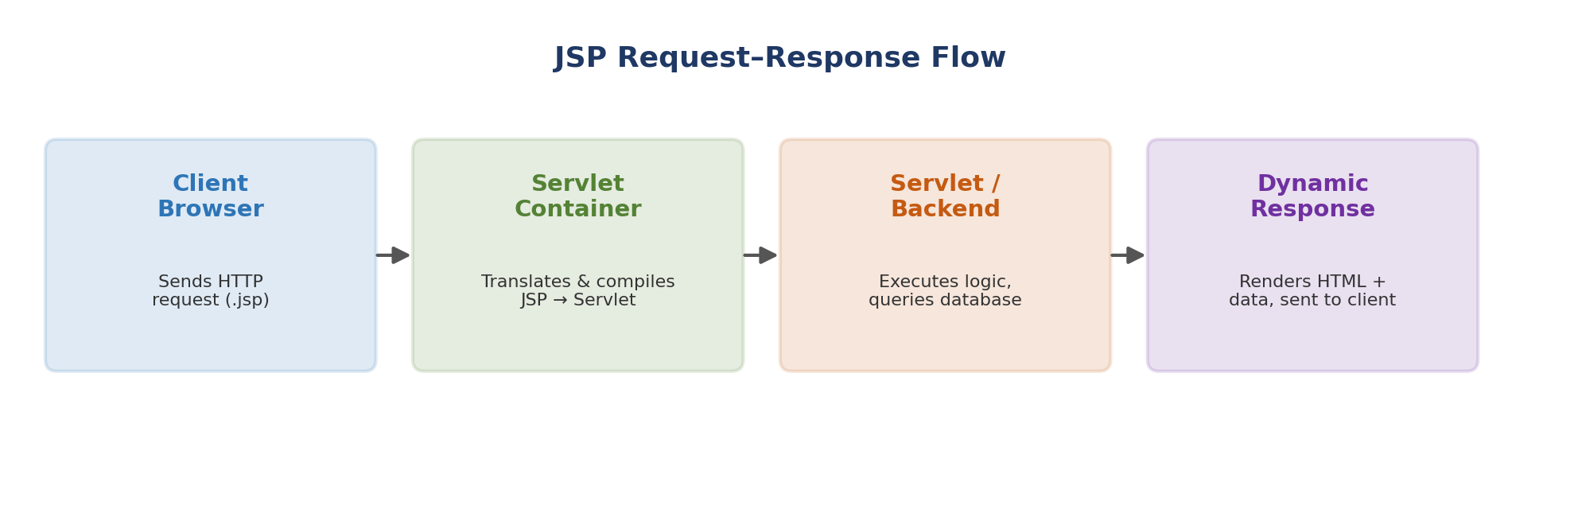
Figure 2: End-to-end JSP request–response flow, from client request to rendered dynamic content.
Pseudocode Algorithm
ALGORITHM JSP_RequestResponseFlow(clientRequest)
BEGIN
// Step 1: Client initiates a request
request ← clientRequest // e.g., browser requests "viewProducts.jsp"

// Step 2: Request reaches the Servlet/JSP Container (e.g., Tomcat)
container ← SERVLET_CONTAINER

// Step 3: Translation and compilation (first request only, or if modified)
IF container.IsFirstRequest(request.jspFile) OR container.IsModified(request.jspFile) THEN
servletSource ← container.TRANSLATE_JSP_TO_SERVLET(request.jspFile)
compiledServlet ← container.COMPILE(servletSource)
container.LOAD(compiledServlet)
END IF

// Step 4: Container invokes the servlet's lifecycle methods
servletInstance ← container.GET_OR_CREATE_INSTANCE(request.jspFile)
CALL servletInstance.service(request, response)
END

FUNCTION servletInstance.service(request, response)
BEGIN
IF request.method == "GET" THEN
CALL doGet(request, response)
ELSE IF request.method == "POST" THEN
CALL doPost(request, response)
END IF
END

FUNCTION doGet(request, response) // or doPost
BEGIN
// Step 5: Interact with backend components if needed
IF request REQUIRES database data THEN
dbConnection ← DATABASE.CONNECT()
query ← BUILD_QUERY(request.parameters)
resultSet ← dbConnection.EXECUTE(query)
dbConnection.CLOSE()
END IF

// Step 6: Embed retrieved data into dynamic content
FOR EACH row IN resultSet
dynamicHTML ← dynamicHTML + FORMAT_ROW_AS_HTML(row)
END FOR
finalResponse ← MERGE(staticHTML_template, dynamicHTML)

// Step 7: Send generated response back to the client
response.SEND(finalResponse)
END
Explanation of Key Steps
- Client request initiation: The flow begins when the browser requests a .jsp resource, either by navigating to a page or submitting a form.
- JSP-to-Servlet translation: The container only needs to translate and compile a JSP page into a servlet once (or after it changes) — subsequent requests reuse the already-compiled servlet instance, which is why first-load is typically slower than later requests.
- Lifecycle dispatch: The container's service() method inspects the HTTP method and routes to doGet() or doPost() accordingly, matching standard Servlet lifecycle behaviour.
- Backend interaction: When dynamic data is required, the servlet/JSP opens a database connection, executes the query, and retrieves the result set — mirroring how a JSP typically delegates data access to a JavaBean or DAO class in practice.
- Dynamic content generation: Retrieved rows are merged with static HTML (the parts of the JSP that don't change) using JSP scriptlets/expression tags, producing the final combined response.
- Response delivery: The finished HTML is sent back over the same HTTP connection, and the browser renders it exactly like any other web page.
Question 4: Database Retrieval
Write a pseudocode algorithm to retrieve data from a database. Your answer should include steps for establishing a database connection, executing SQL queries, processing the result set, and displaying the retrieved data. Clearly represent the sequence of operations involved in database interaction.
Pseudocode Algorithm
ALGORITHM RetrieveDataFromDatabase(host, port, username, password, dbName, tableName)
BEGIN
TRY
// Step 1: Establish a database connection
connection ← DATABASE.CONNECT(host, port, username, password, dbName)

IF connection is NULL THEN
PRINT "Error: Unable to connect to the database"
EXIT
END IF

// Step 2: Prepare and execute the SQL query (parameterized to prevent SQL injection)
query ← "SELECT id, name, email FROM " + tableName + " WHERE status = ?"
preparedStatement ← connection.PREPARE(query)
preparedStatement.BIND_PARAMETER(1, "active")
resultSet ← preparedStatement.EXECUTE_QUERY()

// Step 3: Process the result set
recordList ← EMPTY LIST
IF resultSet.IS_EMPTY() THEN
PRINT "No records found"
ELSE
WHILE resultSet.HAS_NEXT()
row ← resultSet.NEXT()
record ← { id: row.GET("id"),
name: row.GET("name"),
email: row.GET("email") }
APPEND record TO recordList
END WHILE
END IF

// Step 4: Display the retrieved data in readable format
FOR EACH record IN recordList
PRINT record.id + " | " + record.name + " | " + record.email
END FOR

CATCH databaseException AS e
PRINT "Error during database operation: " + e.message

FINALLY
// Step 5: Release resources regardless of success or failure
IF resultSet is NOT NULL THEN resultSet.CLOSE()
IF preparedStatement is NOT NULL THEN preparedStatement.CLOSE()
IF connection is NOT NULL THEN connection.CLOSE()
END TRY
END
Explanation of Key Steps
- Connection establishment: The algorithm first opens a connection using the provided credentials, with explicit error handling if the connection cannot be made.
- Query execution: A parameterized/prepared statement is used rather than directly concatenating values into the SQL string, protecting against SQL injection while executing the query.
- Result set processing: A WHILE loop iterates through every row returned, extracting each column's value into a structured record before adding it to a list — handling both the empty-result and multi-row cases.
- Displaying data: Once all rows are processed, a separate loop prints each record in a clean, column-aligned format.
- Resource cleanup: A FINALLY block guarantees the result set, statement, and connection are always closed, whether the operation succeeded or an exception occurred — preventing connection leaks.
Question 5: PHP Validation
Write a pseudocode algorithm for validating user input in a web form using PHP concepts. The algorithm should include checks for empty fields, validation of input formats (such as email and password), handling invalid inputs with appropriate error messages, and allowing submission only when all validations are satisfied.
Pseudocode Algorithm
ALGORITHM ValidateFormInput()
BEGIN
// Step 1: Proceed only if the form was submitted via POST
IF REQUEST_METHOD == "POST" THEN

errors ← EMPTY LIST
name ← TRIM(POST["name"])
email ← TRIM(POST["email"])
password ← POST["password"]

// Step 2: Check for empty required fields
IF name IS EMPTY THEN
APPEND "Name is required" TO errors
END IF
IF email IS EMPTY THEN
APPEND "Email is required" TO errors
END IF
IF password IS EMPTY THEN
APPEND "Password is required" TO errors
END IF

// Step 3: Validate input formats (only if the field is not already empty)
IF email IS NOT EMPTY AND NOT MATCHES_REGEX(email, "^[\\w.-]+@[\\w.-]+\\.[A-Za-z]{2,}$") THEN
APPEND "Invalid email format" TO errors
END IF

IF password IS NOT EMPTY THEN
IF LENGTH(password) < 8 THEN
APPEND "Password must be at least 8 characters long" TO errors
END IF
IF NOT CONTAINS_UPPERCASE(password) THEN
APPEND "Password must contain at least one uppercase letter" TO errors
END IF
IF NOT CONTAINS_DIGIT(password) THEN
APPEND "Password must contain at least one digit" TO errors
END IF
END IF

// Step 4: Handle validation outcome
IF LENGTH(errors) > 0 THEN
FOR EACH error IN errors
DISPLAY error NEXT TO the corresponding field
END FOR
REPOPULATE form fields WITH (name, email) // password left blank for security
STOP // do not proceed to submission
ELSE
// Step 5: All validations passed — sanitize and process
cleanName ← SANITIZE(name) // strip tags / escape special characters
cleanEmail ← SANITIZE(email)
hashedPassword ← HASH(password) // never store plaintext passwords

SAVE_TO_DATABASE(cleanName, cleanEmail, hashedPassword)
DISPLAY "Registration successful"
END IF
END IF
END
Explanation of Key Steps
- Trigger condition: Validation logic only executes once the form has actually been submitted (checked via the request method), avoiding running checks on an initial, empty page load.
- Empty-field checks: Each required field is checked independently so the user receives a specific message for every missing field at once, rather than stopping at the first error.
- Format validation: Email format is checked using a regular expression, and password strength is checked against multiple rules (length, uppercase, digit) — these checks only run if the field isn't already flagged as empty, avoiding redundant or confusing error messages.
- Error handling: All collected error messages are displayed next to their relevant fields, and non-sensitive field values (name, email) are retained so the user doesn't have to retype everything, while the password field is deliberately left blank for security.
- Conditional submission: The record is only sanitized, hashed, and saved to the database if the errors list is completely empty, ensuring invalid data can never reach the backend — and the password is hashed rather than stored in plaintext, following secure PHP development practice.
Code of Conduct:
I K. Sai Kumar(192372080)(Name / Reg No) certify that this submission is my original work and that I have adhered to the guidelines specified for this assessment. I understand that any violation of academic integrity rules will result in disciplinary action.
Signature of the student: ______________________
RUBRICS FOR CALCULATION
Criteria | Weightage | Level 4 – Exemplary | Level 3 – Proficient | Level 2 – Developing | Level 1 – Beginning
Problem Understanding | 20% | Identifies all inputs, outputs, constraints accurately | Minor missing elements | Partial understanding | Incorrect interpretation
Algorithm Design | 30% | Complete, correct, and logically sound solution | Minor logical gaps | Partially correct logic | Incorrect approach
Use of Control Structures | 20% | Efficient and appropriate use of loops, conditions, functions/modules | Minor inefficiencies | Limited or basic usage | Incorrect or missing constructs
Pseudocode Structure | 10% | Well-structured, clear, consistent format, easy to follow | Mostly clear with minor issues | Difficult to follow in parts | Poorly structured and unclear
Completeness | 20% | Handles all cases; optimized approach | Handles most cases; reasonable efficiency | Handles basic cases only | Incomplete or inefficient

